**Jaime Rodriguez**

**ECE 311 Feedback & Control**

**HW #6, 5-17-2015**

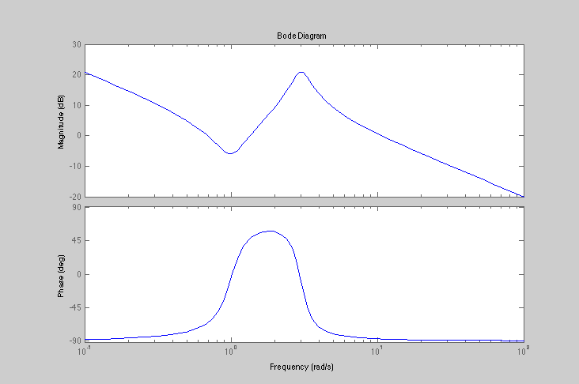

**7-4)**

s=tf('s');

g=(10*(s^2+.4*s+1))/

(s*(s^2+.8*s+9));

bode(g);

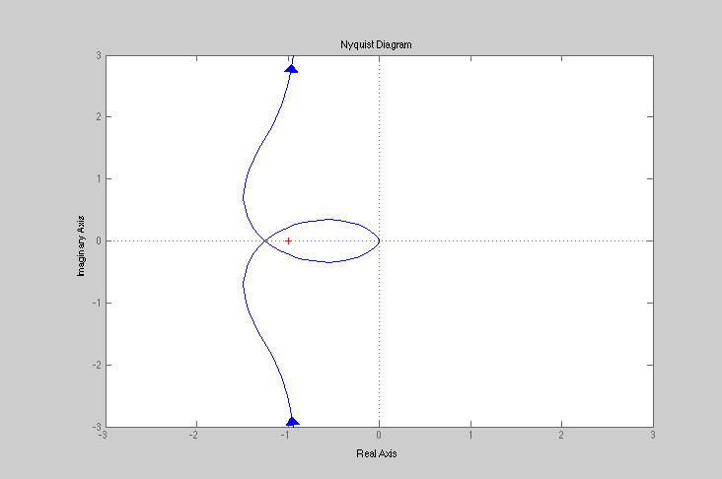

**7-12)**

clc

clear

s=tf('s');

g= 1 / (s*(s^2+.8*s+1));

nyquist(g);

xlim ([-3,3]);

ylim ([-3,3]);

**7-18)**

clc

clear

legend('k=1','k=10','k=100');

s=tf('s');

k=[1,10,100];

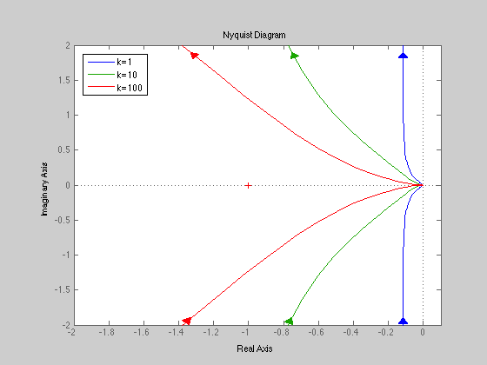for n=1:1:3

g= (k(n)*(s+2)) /(s*(s+1)*(s+10));

nyquist(g);

hold on

xlim ([-2,.1]);

ylim ([-2,2]);

end

**7-25)**

clc

clear

s=tf('s');

g= (20*(s+1))/(s*(s^2+2*s+10)*(s+5));

bode(g);

[Gm,Pm,Wcg,Wcp] = margin(g)

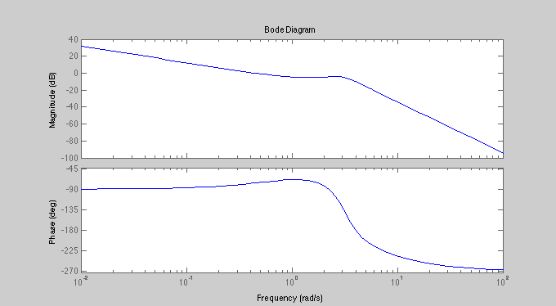Gmdb=20*log10(Gm)

Gmdb =

9.9301 dB

Pm =

103.6573

Wcg =

4.0132

Wcp =

0.4426

**7-28)**

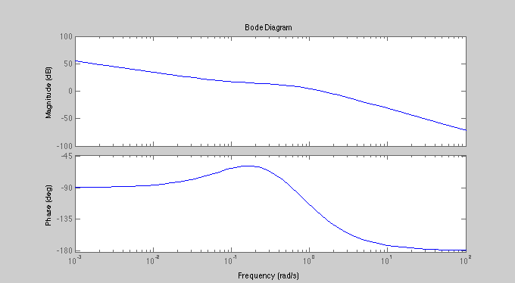

clc

clear

s=tf('s');

k=.266;

g= (10*k*(s+.1)) / (s*(s+1)*(s+.5));

bode(g);

[Gm,Pm,Wcg,Wcp] = margin(g)

Gmdb=20*log10(Gm)

Gmdb =

Inf

Pm =

50.0118

Wcg =

Inf

Wcp =

1.4379

K =.266 , value was found by varying k until Phase margin was 50

**Problem #1**

clc

clear

s=tf('s');

g= (39.8*(s+1))/(s*(s+10)^2);

bode(g);

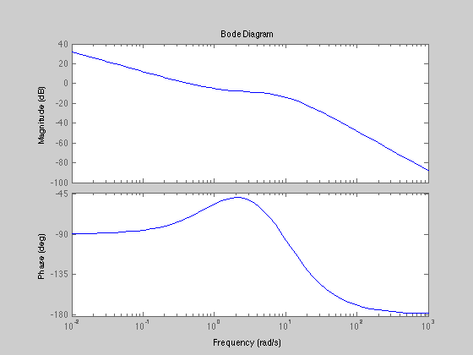

**Problem#2**

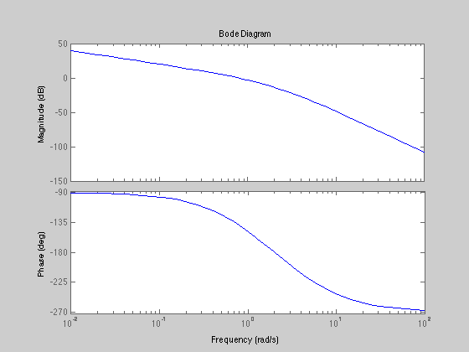

clc

clear

s=tf('s');

l=4/(s*(s+1)*(s+4));

bode(l)

[Gm,Pm,Wcg,Wcp] = margin(l)

Gmdb=20*log10(Gm)

**b)**

**Gmdb = 13.9794**

**Pm = 41.2246**

**c)**

**K=5**

**Gmdb =12.0065**

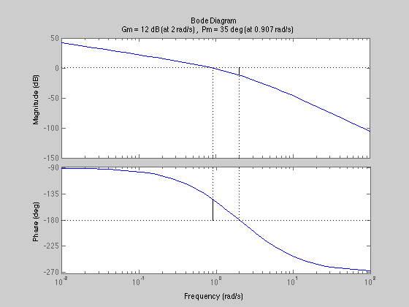

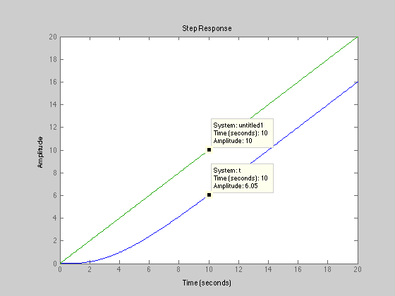**d)**

**K needs to be 1 to give a 25% ess**

**e)**

**Stable no sign change in the Routh array**

**f)**

